Your magazine Title

Editors

RK Publications

RK Publications
India| Brazil| Kenya
1st Edition - 2025
ISBN - 978-93-47046-33-9
Date of Publication - 15/10/2025
Language – English
This book has been published with all reasonable efforts taken to make the material error-free after the consent of the author. No part of this book shall be used, reproduced in any manner whatsoever without written permission from the author, except in the case of brief quotations embodied in critical articles and reviews.
The Author of this book is solely responsible and liable for its content including but not limited to the views, representations, descriptions, statements, information, opinions and references [“Content”]. The Content of this book shall not constitute or be construed or deemed to reflect the opinion or expression of the Publisher or Editor. Neither the Publisher nor Editor endorse or approve the Content of this book or guarantee the reliability, accuracy or completeness of the Content published herein and do not make any representations or warranties of any kind, express or implied, including but not limited to the implied warranties of merchantability, fitness for a particular purpose. The Publisher and Editor shall not be liable whatsoever for any errors, omissions, whether such errors or omissions result from negligence, accident, or any other cause or claims for loss or damages of any kind, including without limitation, indirect or consequential loss or damage arising out of use, inability to use, or about the reliability, accuracy or sufficiency of the information contained in this book.
Price - INR 1999 Head office -Saravanampatti
Coimbatore, India
  - Editors

Editors detail:

Editors detail:

00 - introduction
01 - chapter title
Contents
02 - chapter title
03 - chapter title
04 - chapter title

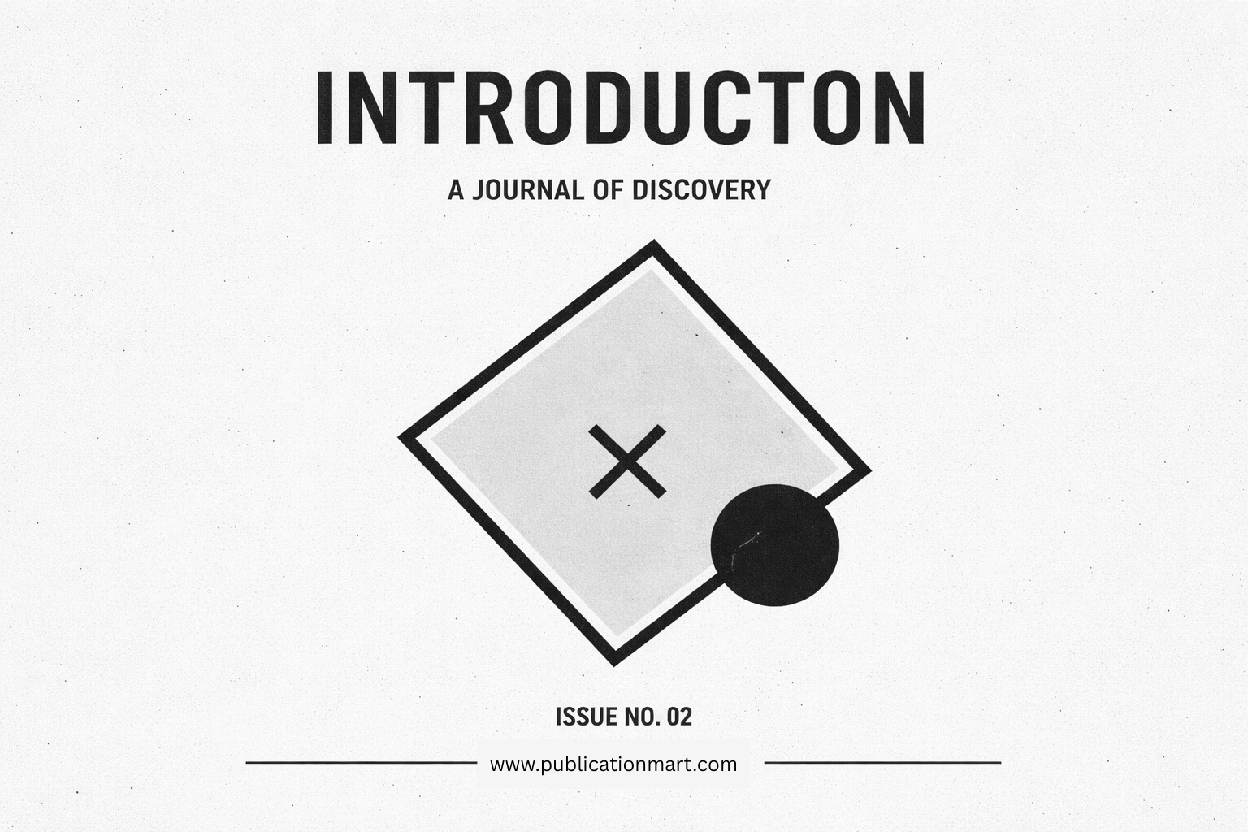

00 – Introductions
An introduction page sets the tone for a magazine by establishing its purpose, vision, and editorial direction. It functions as a gateway that prepares readers for the ideas and narratives that follow. Through concise language and thoughtful structure, the introduction communicates what the publication values and why it exists. A well-crafted introduction highlights curiosity, creativity, and relevance, drawing attention to the themes explored in the issue. It often reflects the cultural, social, or intellectual context in which the magazine is produced, creating immediate resonance with its audience. By presenting clarity and intention, the introduction reassures readers that the content has been carefully curated. Typography, layout, and visual balance further support the message, reinforcing a sense of professionalism and identity. When executed effectively, the introduction page becomes more than a formality; it becomes an invitation to engage, explore, and reflect, encouraging readers to continue with interest and anticipation.

Sub headings
Magazines frequently use the introduction to articulate a central theme that connects diverse articles into a cohesive whole. This thematic framing helps readers understand how individual stories relate to broader ideas. Whether focused on discovery, innovation, culture, or reflection, the introduction provides context without revealing too much detail. It balances mystery with guidance, allowing curiosity to guide the reading experience. Editorial intent is subtly conveyed through tone and word choice, signaling whether the issue emphasizes analysis, inspiration, or exploration. The introduction may also acknowledge changing perspectives or emerging trends, positioning the magazine as timely and relevant. By grounding the issue in a clear conceptual foundation, the introduction strengthens coherence and depth. Readers gain a sense of direction, enabling smoother transitions between sections while maintaining engagement throughout the publication.
Design simplicity often enhances the effectiveness of an introduction page by focusing attention on essential elements. Minimalist layouts, restrained color palettes, and symbolic graphics can communicate sophistication and clarity. Visual metaphors, such as geometric forms or abstract shapes, reinforce themes of balance, inquiry, or transformation. White space plays a critical role by allowing content to breathe and reducing cognitive overload. This design approach supports readability and encourages thoughtful engagement rather than distraction. When text and visuals align harmoniously, the introduction achieves emotional resonance without excessive ornamentation. Such restraint reflects editorial confidence, suggesting that the content speaks for itself. Readers are subtly guided to slow down, absorb meaning, and prepare for deeper exploration, reinforcing the magazine’s identity as intentional and refined.

Sub headings
Language used in an introduction page often reflects the magazine’s audience and scope. Clear, inclusive phrasing welcomes both new and returning readers, avoiding unnecessary complexity. Sentences are crafted to be fluid and engaging, maintaining momentum while delivering insight. The introduction may reference shared experiences, universal questions, or collective aspirations, fostering a sense of connection. This approach builds trust and encourages readers to invest time in the publication. Without overwhelming detail, the introduction establishes credibility and relevance. Editorial voice remains consistent with the magazine’s broader tone, whether academic, creative, or reflective. Through balanced expression and thoughtful pacing, the introduction sets expectations while leaving room for discovery within the pages that follow.
Ultimately, the introduction page serves as a narrative anchor for the entire magazine. It aligns content, design, and purpose into a unified opening statement. By emphasizing curiosity and thoughtful exploration, the introduction encourages readers to engage actively rather than passively consume information. It reinforces the idea that each issue represents a journey shaped by research, creativity, and editorial care. When readers feel guided rather than instructed, a stronger relationship with the publication is formed. The introduction thus becomes a promise of quality and intention, signaling that the magazine values depth, clarity, and meaningful storytelling. This foundational role ensures that the reading experience begins with focus and inspiration, setting a lasting impression that carries through every subsequent page.



01 – Chapter title
The opening chapter introduces the magazine’s core philosophy and sets a reflective yet engaging tone for readers. This section explains why the journey begins here and how curiosity drives meaningful discovery. The narrative emphasizes clarity, purpose, and openness to ideas that shape understanding across disciplines. Readers are guided to view the chapter as a foundation rather than a conclusion, encouraging active engagement with the content ahead. The language remains accessible while maintaining depth, ensuring broad appeal without losing intellectual value.

Figure1: figure name Figure2: figure name
Key focus points:
- Establishing the theme and direction of the issue
- Encouraging curiosity and reflective thinking
- Introducing the editorial vision clearly
- Preparing readers for diverse perspectives
- Creating a smooth transition into detailed sections

Understanding the Theme of the Issue
This section explains the central theme that connects all articles in the magazine. It outlines how individual stories, features, and visuals align with a shared concept. The emphasis remains on coherence and relevance, helping readers recognize patterns and relationships across content. The chapter avoids exhaustive detail, instead offering guidance that allows exploration to unfold naturally. Contextual framing strengthens reader comprehension while preserving curiosity.

Figure 3:Figure name Figure 4:Figure name
Highlights covered:
- Explanation of the issue’s main theme
- Relationship between articles and visuals
- Relevance to current cultural or intellectual trends
- Balance between guidance and discovery
- Conceptual continuity across sections

Editorial Approach and Creative Direction
This paragraph focuses on how content has been curated and presented. It discusses the balance between creativity and structure, ensuring that ideas flow logically while retaining originality. Attention is given to tone, design consistency, and narrative rhythm. The editorial approach reflects intentional planning, reinforcing trust and credibility. Readers gain insight into how thoughtful selection enhances clarity and engagement.

Figure 5: Figure name
- Editorial principles include:
- Consistent tone and voice
- Purpose-driven content selection
- Visual and textual harmony
- Emphasis on readability and flow
- Alignment with magazine identity

What Readers Can Expect Ahead
The final paragraph outlines what lies beyond the first chapter without revealing specifics. It builds anticipation while maintaining focus and restraint. Readers are encouraged to explore with an open mindset, understanding that each section adds depth to the overall narrative. The chapter closes by reinforcing continuity and purposeful progression.


02 – Chapter title

Expanding the Horizon
This chapter builds upon the foundation established earlier by widening the scope of ideas and perspectives. It focuses on growth through observation, experience, and thoughtful analysis. The narrative encourages readers to move beyond familiar patterns and engage with new viewpoints that challenge routine thinking. Emphasis is placed on continuity, ensuring that exploration feels progressive rather than fragmented. The tone remains reflective, allowing concepts to develop organically while maintaining clarity. Readers are guided to connect personal insight with broader themes, creating relevance and depth. The chapter acts as a bridge between introduction and deeper exploration, strengthening understanding without overwhelming detail.

Figure 1: Figure name Figure 2: Figure name
Core elements highlighted:
- Gradual expansion of concepts
- Encouragement of reflective thinking
- Connection between ideas and experience
- Smooth narrative progression
- Reinforcement of thematic continuity

Themes, Insights, and Reader Engagement
The second section of this chapter concentrates on engagement and interpretation. It explains how themes are translated into meaningful insights through stories, visuals, and structured commentary. Readers are encouraged to interpret content actively, forming connections that extend beyond the page. The chapter values balance between guidance and freedom, allowing ideas to resonate individually. Clear organization supports comprehension, while subtle prompts invite curiosity. This approach deepens reader involvement and reinforces the magazine’s purpose.

Figure 3: Figure name Figure 4: Figure name
Key takeaways include:
- Active reader participation
- Thoughtful presentation of insights
- Alignment of visuals and narrative
- Clarity through structured content
- Invitation to personal interpretation

Figure 5: Figure name

